 | Title : Project Registration & Progress Review |  | FF No. 180
Department: AI&DS |  | Academic Year: 2025-2026
Semester: II |  | Group No. : SY_AIDS_B_13
Project Title: AI BASED TAX CALCULATION SYSTEM
Project Area: TAXATION & FINANCE
Group Members Details:

Sr. No. | Class & Div. | Roll No. | G.R.No. | Name of Student | Contact No. | Email ID
1 | SY B | 39 | 12413493 | kavyanjali Gavate | 7028683396 | kavyanjali.gavate24@vit.edu
2 | SY B | 44 | 12410890 | Swachhand Ghodke | 9272188593 | swachhand.ghodke24@vit.edu
3 | SY B | 48 | 12411047 | Shavi Gongale | 7822943497 | Shavi.gongale24@vit.edu
4 | SY B | 50 | 12414457 | Devansh Goyanka | 9423411831 | devansh.goyanka24@vit.edu
5 | SY B | 56 | 12411097 | Aishwarya Hirapure | 7756073988 | aishwarya.hirapure24@vit.edu

Name of Internal Guide: Prof. Dr. Sheela Chinchmalatpure Contact No. & Email ID: 9545456623, Sheela.chinchmalatpure@vit.edu

Project approved / Not approved

Guide Project Coordinator Head of Department

T

1. Introduction

Tax computation in India involves analysis of multiple financial documents such as Form 26AS, AIS (Annual Information Statement), TIS (Taxpayer Information Summary), and Form 16. Chartered Accountant firms manually compute tax liability, compare old and new tax regimes, select appropriate ITR forms, and advise clients on tax-saving strategies.
This project proposes an AI-driven Income Tax Utility sponsored by ADP & Co. (Chartered Accountants) to automate tax computation, regime comparison, ITR selection, and intelligent tax-saving recommendations. The system will generate a validated computation sheet compatible with the Income Tax e-Filing Portal and enable client communication via Email/WhatsApp.

2. Literature Survey
Literature survey (5–6 key papers)
Paper 1: AI-Based Tax Compliance Systems
Researchers have explored AI-driven compliance frameworks that automate tax rule interpretation and return validation. These systems apply rule-based engines combined with machine learning to detect anomalies in filings.
Limitation: Most models focus on fraud detection rather than intelligent tax optimization or regime comparison.

Paper 2: Intelligent Financial Document Processing Using NLP
Several studies demonstrate automated extraction of financial information from structured and semi-structured documents using OCR and Natural Language Processing. Transformer-based models improve accuracy in extracting salary, TDS, and investment details.
Limitation: These models stop at extraction and do not integrate with statutory tax computation logic.

Paper 3: Expert Systems for Tax Advisory
Expert systems using rule-based inference engines have been proposed to simulate Chartered Accountant decision-making for deductions under Sections 80C, 80D, 80E, etc.
Limitation: Lack dynamic adaptation to new tax regime rules and fail to provide comparative regime evaluation.

Paper 4: Regime Optimization Using Decision Algorithms
Decision-tree-based approaches have been used to compare tax liabilities under different slab structures. These systems apply deterministic computation to choose minimal payable tax.
Limitation: These systems do not incorporate predictive advisory or behavioral financial optimization.

Paper 5: Automated ITR Form Classification Systems
Classification models using income head segmentation have been proposed to recommend suitable return forms (ITR-1 to ITR-4).
Limitation: They rely on static income categorization and lack validation against compliance constraints of the e-filing schema.

Paper 6: AI in Financial Planning and Investment Optimization
Machine learning models have been used for portfolio optimization and tax-efficient investment allocation using predictive analytics.
Limitation: These systems operate independently of statutory Indian Income Tax provisions and are not integrated with real-time tax computation engines.

3. Gap Analysis
Existing systems either focus on document extraction, fraud detection, or financial advisory independently. There is no integrated AI-driven system that combines document parsing, statutory tax computation, regime optimization, ITR selection, and predictive tax-saving advisory aligned with Indian Income Tax e-filing validation rules.

4. Problem Statement
Current tax computation processes in CA firms are manual, repetitive, and lack intelligent automation for regime optimization and proactive advisory.
There is a need for an integrated AI-driven system that automates tax computation, ensures compliance accuracy, selects appropriate ITR forms, and generates intelligent tax-saving recommendations.

5. Methodology
The proposed system will follow a modular architecture consisting of five layers:

5.1 Data Acquisition Layer
- Upload of Form 26AS, AIS, TIS, and Form 16 (PDF/JSON/XML).
- OCR and structured parsing using NLP-based extraction.
- Schema validation and cross-verification of TDS/TCS.

5.2 Data Processing & Mapping Layer
- Income classification into:
  - Salary
  - House Property
  - Capital Gains
  - Business/Profession
  - Other Sources
- Deduction mapping as per Income Tax Act provisions.
- Validation checks for inconsistencies.

5.3 Tax Computation Engine
Old Regime Module
- Slab calculation
- Chapter VI-A deductions (80C, 80D, 80CCD, etc.)
- Rebate under Section 87A
- Surcharge computation
- Health & Education Cess (4%)
- Interest u/s 234A, 234B, 234C
New Regime Module
- Revised slab application
- Standard deduction (if applicable)
- Limited deduction structure
- Automatic comparison of regimes

5.4 ITR Selection Logic
A rule-based inference engine will determine the suitable ITR form:
Income Heads Present | Suggested ITR
Salary + Other Sources | ITR-1
Capital Gains | ITR-2
Business/Profession | ITR-3
Presumptive Income | ITR-4
Validation will ensure alignment with e-filing portal schema requirements.

5.5 AI-Based Tax Optimization Module
- Predict optimal allocation under:
  - Section 80C (ELSS, PPF, LIC)
  - Section 80D (Health Insurance)
  - Section 80CCD(1B) (NPS)
  - Capital Gains exemptions (54, 54F)
- Comparative advisory between FD, equity, and reinvestment planning.
- Generation of structured advisory summary for clients.

5.6 Output & Integration Layer
- Generate validated computation sheet.
- Export in portal-compatible format.
- Client communication module (Email/WhatsApp integration).
- Dashboard for CA review and manual override.

6. Technology Stack

- Frontend: Typescript, Nextjs, React
- Backend: Java (Spring Boot Framework)
- Database: PostgreSQL
- AI Module: ML model using Python integrated via REST APIs (optional microservice architecture)
- Reporting: PDF/JSON export module
- Notification: Email SMTP + WhatsApp API Integration

7. Database Design (Tables)
- Users
- Clients
- Income_Details
- Deduction_Details
- Tax_Computation_Old
- Tax_Computation_New
- ITR_Type
- Advisory_Recommendations
- Uploaded_Documents

8. Expected Outputs
- Net Tax Payable
- Old vs New Regime Comparison
- Best Regime Auto-Selected
- Manual Regime Change Option
- Auto-Selected ITR
- Validated Computation Sheet
- AI-Based Tax Saving Advisory Report

9. Database Design (Tables)
- Users
- Clients
- Income_Details
- Deduction_Details
- Tax_Computation_Old
- Tax_Computation_New
- ITR_Type
- Advisory_Recommendations
- Uploaded_Documents

10. Architecture Diagram

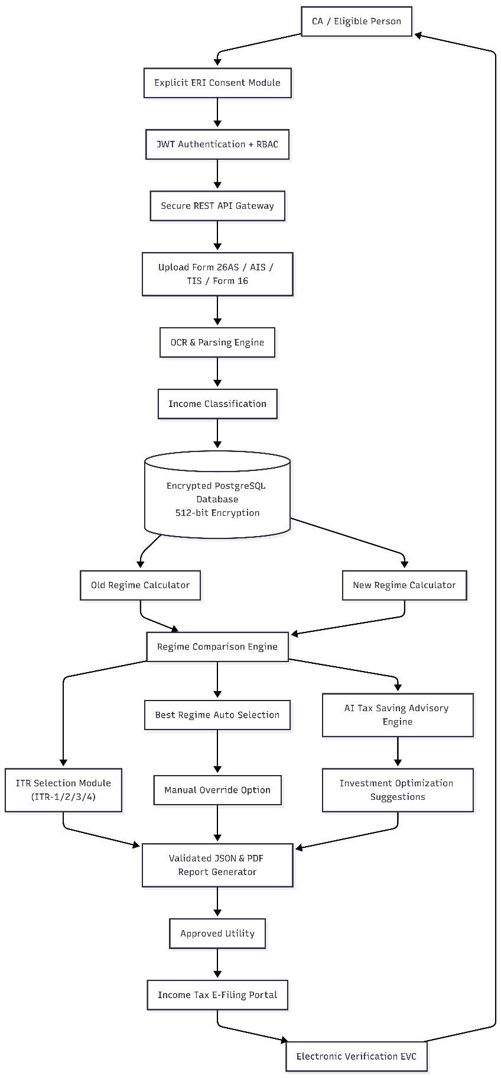

11. Expected Outputs
- Net Tax Payable
- Old vs New Regime Comparison
- Best Regime Auto-Selected
- Manual Regime Change Option
- Auto-Selected ITR
- Validated Computation Sheet
- AI-Based Tax Saving Advisory Report
- Email/WhatsApp Client Report Delivery

12. Unique Features
- Intelligent Regime Optimization
- Automated ITR Mapping
- AI-driven investment advisory
- Sponsor-specific tax computation formulas
- Portal-compatible validated output
- End-to-end automation for CA firms

13. Scope

The system is intended for:
- Individual taxpayers
- CA firms
- Financial advisory firms
It can later be extended for:
- GST integration
- Corporate tax computation
- TDS return automation

14. Conclusion

The proposed AI-Based Income Tax Utility will reduce manual workload, improve computational accuracy, enhance advisory capability, and provide structured compliance support to CA firms. The system aligns with sponsor requirements and leverages AI for predictive tax optimization, making it a modern and practical financial technology solution.

Group No. | SY_AIDS_B_13
Activity | Review Schedule | Progress Review Report submitted | Signature of Guide
Review 1 | Mid Sem. Semester | Yes / No
Review 2 | End of Semester | Yes / No

Format of Progress Review Report:

Review No.: 1 Group No.: Date:

Progress Review Report

Signature of Guide:

Review No.: 2 Group No.: Date:

Progress Review Report

Signature of Guide:

